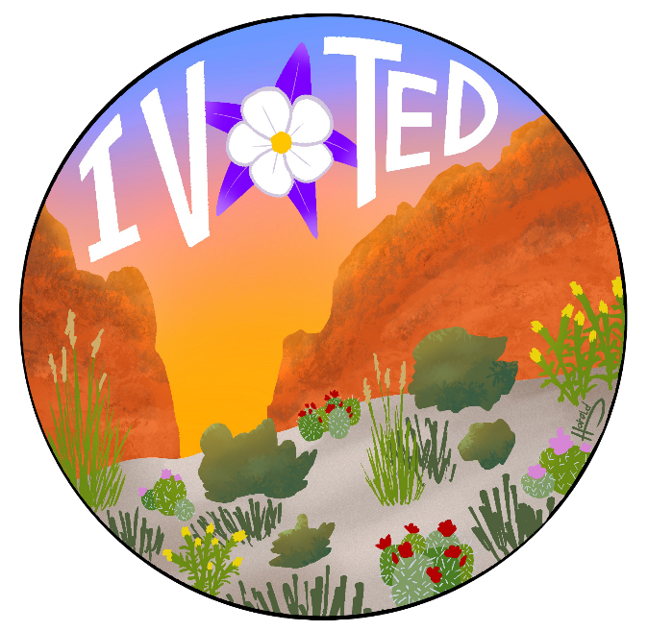
Colorado Digital “I Voted” Sticker Partner Toolkit

This kit includes:

- Link to I Voted Digital Sticker Contest website
- Link to I Voted Digital Sticker Template
- Link to Submission and Release form
- Contest Submission Dates
- Contest Description and Rules
- Sample social media posts and graphics
- Sample outreach to potential participants
- Sample outreach to distribution partners
- Printable flyers
Cosmo B.’s winning digital
“I Voted” sticker design from 2024

Contest Submission Dates:
- Monday, March 16, 2026 – Friday, September 4, 2026

Contest Rules:
- All entrants must be 13 - 18 years old and enrolled in a Colorado high school or Colorado homeschool program.
- All artwork submitted must be your original work; no stock or borrowed images may be used.
- Artwork with offensive language, violence, drugs, gangs, weaponry, etc. will not be considered.
- Entries must include the words “I Voted”.
- Artwork must be nonpartisan.
  - Entries may be created on paper or digitally.
  - Paper entries must be either scanned or photographed clearly for submission.
- Digital & paper files must be under 1GB, and must be a .pdf, .png, .jpg, or jpeg.
- If the winner submitted artwork created on paper, the Colorado Secretary of State’s Office will provide a pre-paid envelope for the artwork to be mailed for image processing to create the digital image, if necessary. The artwork will be returned to the artist after processing.
- Entries will be used for social media and other marketing materials for the Colorado Secretary of State’s Office.

Sample Social Media Copy and Graphics
- Colorado high school artists [OR TK HIGH SCHOOL NAME students]! @COSecOfState’s “I Voted” digital sticker contest is on! You could design the digital stickers that voters get after they cast their ballot. Learn more at GoVoteColorado.gov.

- Your design could be the next official Colorado "I Voted" digital sticker! @COSecOfState is hosting a statewide competition for high schoolers to create a new digital sticker for the November Election. Visit GoVoteColorado.gov for more info!

- CO high school students – you have a chance to use your creativity to encourage civic engagement. Whether you love democracy, graphic design or both, your art could be Colorado’s newest “I Voted” digital sticker! Follow @COSecOfState for additional info.

- Submissions for the “I Voted” digital sticker contest are due by September 4! Show your passion for democracy and encourage Coloradans to vote – submit your designs today at GoVoteColorado.gov. Follow @CoSecOfState for more information.

- CO high school students have a chance to have their design featured statewide during the upcoming election. September 4 is the deadline to submit artwork at GoVoteColorado.gov! Follow @CoSecOfState to find out when the winner will be announced!

- Design Colorado’s newest “I Voted” digital sticker and you could have your artwork featured on @COSecOfState’s social channels, election day communications, and sent directly to voters who have cast their ballot. Learn more and submit your artwork at GoVoteColorado.gov. The submission deadline is September 4!

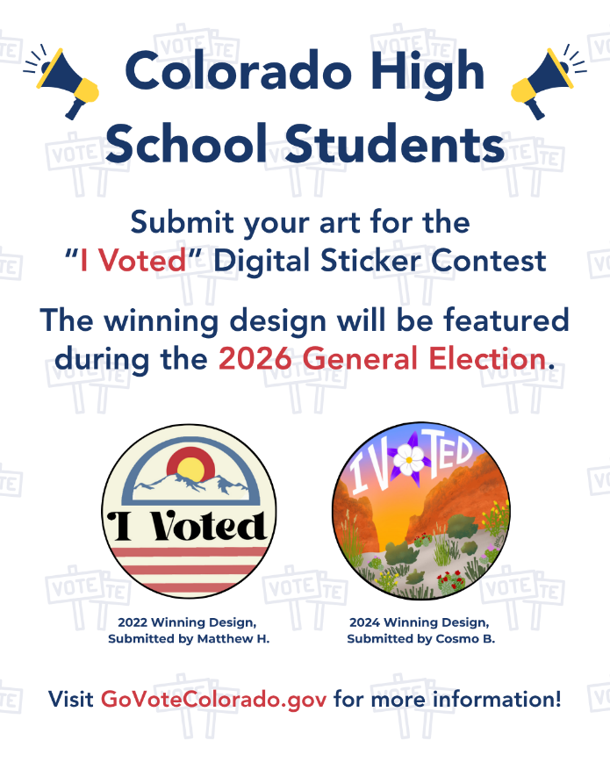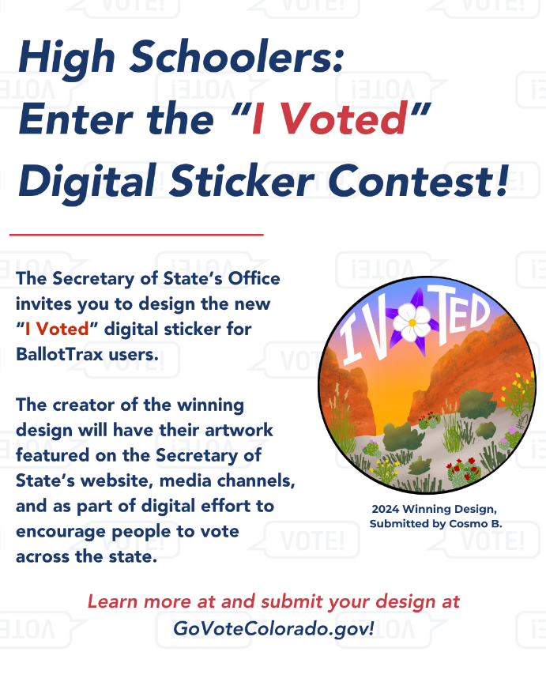
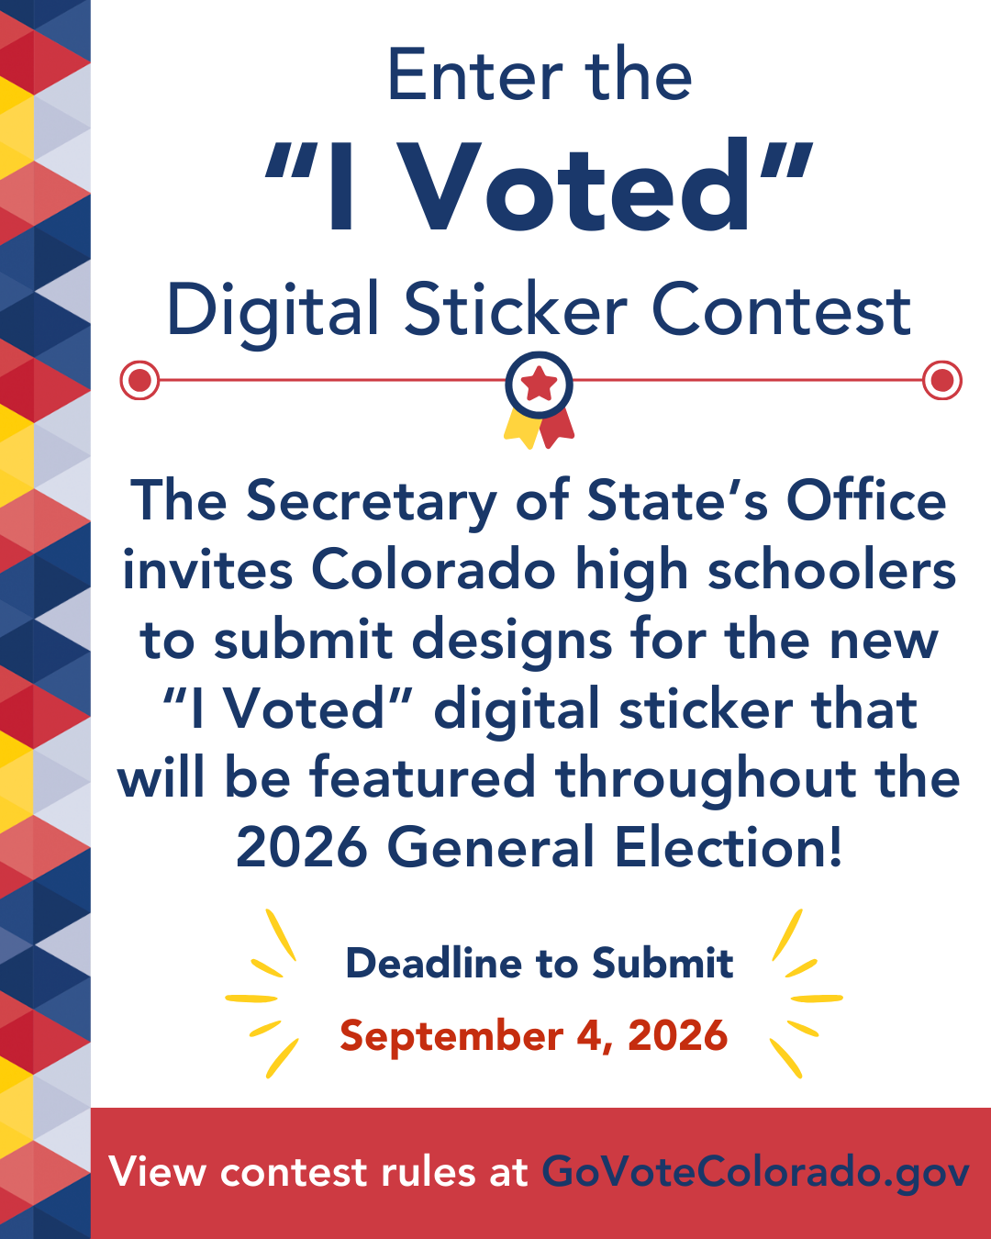

Sample outreach to potential participants
Hello [NAME],
I hope you’re doing well!

The Colorado Secretary of State’s Office has announced a competition for students to submit artwork for a new digital “I Voted” sticker that runs until Friday, September 4, 2026. They are accepting design submissions from high school students for the contest.

The creator of the winning design will have their artwork featured on the Secretary of State’s website, media channels, and as part of digital effort to encourage people across Colorado to vote. It will also be sent directly to every Colorado voter enrolled in Colorado BallotTrax after they’ve cast their ballot.

You can learn more and submit your artwork for consideration at www.GoVoteColorado.gov. And don’t forget to spread the word!

Please let me know if you need any additional assistance.

Thanks!
[TK NAME.]

Sample outreach to potential distribution partners from CDOS staff
Hello [NAME],
I wanted to share an amazing opportunity for students from the Colorado Secretary of State’s Office. From Monday, March 16, 2026 – Friday, September 4, 2026, we’ll be accepting design submissions from Colorado high school students who want to help create a new, “I Voted” digital sticker for the November General Election.

The creator of the winning design will have their artwork featured on the Secretary of State’s website, media channels, and as part of digital effort to encourage people to vote across the state. The winning design will also be sent to all Colorado BallotTrax users after they have cast their ballot!

I’d love for you to spread the word about this opportunity. I’ve attached an outreach toolkit provided by the Department of State that includes everything you need to know about the digital sticker contest.

Would you be willing to share this exciting opportunity with your channels?

Thank you, and please let me know if you have any questions!
[Name]

Digital Flyers for School Use
